Exercises- Predicate Logic
Exercise 1
Transform the following sentences from natural language into predicate formulas. Explain the syntactic elements used in the predicate formulas: variables, constants, functions symbols, predicate symbols.
- The sum and difference of two even numbers is an even number and their product is divisible by 4.
- If is a nonzero integer divisible by 10, it can be decomposed in two factors such that one is divisible by 2 and the other one is divisible by 5, and can be written as a sum of 2 even numbers.
- Every positive number can be written as a product of two positive numbers and as a product of two negative numbers.
- If and are positive prime numbers, 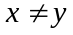, 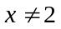 and 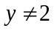, their sum and difference are even numbers and their product is an odd number.
- For every positive integer , if is a square of an integer, then there exists an integer y such that 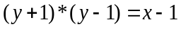.
- If x is divisible by 3 and y is divisible by 6 then their product is an even number and their sum is divisible by 3.
- For every positive integer, if is not a prime, then there exists a prime such that divides and < .

Exercise 2
Transform the following statements from natural language into predicate formulas choosing the appropriate constants, function symbols and predicate symbols:
- Every student who makes good grades is brilliant or studies.
- Some of John’s colleagues like to draw and some like to dance.
- CS students like either algebra or logic, all of them like Java but only Bill likes history.
- All Mary’s relatives live in Cluj-Napoca, only her cousin John lives in Bucharest.
- Caterpillars and snails like to eat some plants.
- Anyone who owns a rabbit hates anything that chases a rabbit.
- Anyone who loves some candy is not a nutrition fanatic.
- If Santa has some reindeer with a red nose, then every child loves Santa.
- Anyone who has any cats will not have any mice.
- Caterpillars and snails are much smaller than birds, which are much smaller than foxes, which in turn are much smaller than wolves.
- Every animal either likes to eat all plants or all animals much smaller than itself that like to eat some plants.
- If every roommate of every CS major likes to party, then every student who is a CS major and makes good grades is brilliant.
- If Santa is happy at Christmas, then every child who is good gets some toy at Christmas.
- Wolves do not like to eat foxes or grains, while birds like to eat caterpillars but not snails.

Exercise 3.
Check whether the conclusion  is derivable from the set of hypotheses using the definition
of deduction and the appropriate inference rules.
1. Succession to the British throne
Hypotheses:
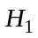. If is the king and is his oldest son, then can become the king.
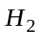. If is the king and defeats , then will become the king.
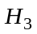. 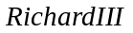 is the king.
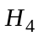. 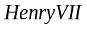 defeated .
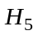. 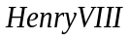 is ’s oldest son.
Conclusion:. Can become the king?

Exercise 4
Using the given interpretations evaluate the following formulas:

Interpretation 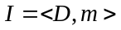, where 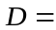 N (the set of natural numbers)
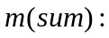N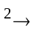N, 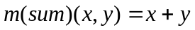 and
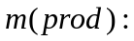NN, 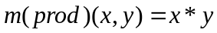
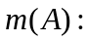N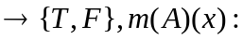”x is an odd number”,
Interpretation where N (the set of natural numbers)
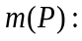N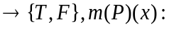”x5”;
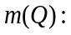N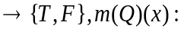”x7”;

Interpretation , where: the set of all straight lines of a plane
Let 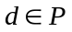, a constant straight line belonging to the interpretation domain
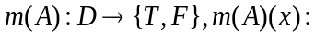”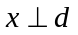”;
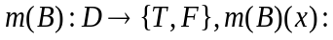”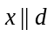”;

Interpretation , where Z (the set of integer numbers),
Z”x is even”;
Z”x<0”;
ZZ,
m(sq):Z -> Z, m(sq)(x)=x^{2.}
Interpretation , where:
N (the set of natural numbers)
”x is a prime”;
”x is an odd number”.

Interpretation , where:
the set of all persons from Romania
” likes chess”;
” is a student”.

- .
Interpretation , where:
the set of all persons from Romania
” owns a car”;
” has a driver licence”.
Exercise 5
Choose an arbitrary interpretation with a finite domain (2 elements) for the formula 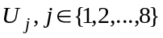
and prove that it is a model of .
- ;
- ;
- ;
- ;
- ;
- ;
- ;
- .

Exercise 6
Find a model and an anti-model for the following formulas:
- ;
- ;
- ;
- ;
- ;
- .

